***Resume Of***

**Md. Ishak Ahammed**

**Mailing Address:**

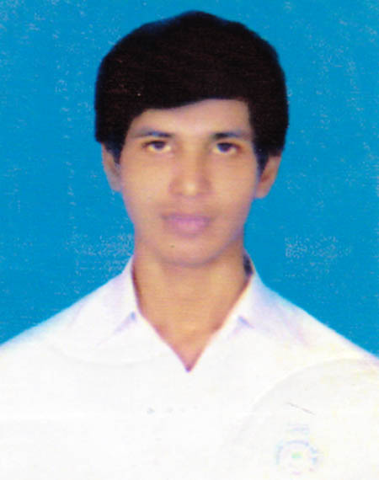

Name: Md. Ishak Ahammed

Address: House no. 75, Road #3, Katasur, Mohammadpur, Dhaka.

**Contact No. :** +8801977537988

**Email address:** ahammed35-1162@diu.edu.bd

**Career Objective:**

I am looking forward to pursue my career in a prominent institute where there are opportunities for learning and growth with utilization of my interpersonal skills, creativity, and intense analytical knowledge. By exploiting best my educational knowledge and experience with my merit, hard work and sincerity; I am committed to develop my own career as well as to serve the institute to meet its desired goal.

**Educational Qualification:**

**Bachelor of Science (BSc)**

Institute Name : Daffodil International University

Department : Software Engineering

CGPA Obtained : CGPA 3.75 (on scale of 4.00)

Session : Running.

**Higher Secondary Certificate (H.S.C)**

Institute Name : Government Laboratory High School.

Board Name : Dhaka.

Group : Science

GPA Obtained : 4.10 (on scale of 5.00)

PassingYear : 2014

**Secondary School Certificate (S.S.C)**

Institute Name : Mohammadpur Government High School

Board Name : Dhaka

Group : Science

GPA Obtained : 5.00 (on scale of 5.00)

Passing Year : 2012

**Personal Details:**

* Name : Md. Ishak Ahammed.
* Father’s Name : Md. Abdul Halim.
* Mother’s Name : Josna Begum.
* Date of Birth : 20th July 1997
* Religion : Islam.
* Marital Status : Unmarried.
* Nationality : Bangladeshi.
* Sex : Male
* Permanent Address : House no. 75, Road #3, Katasur, Mohammadpur, Dhaka.
* Present Address : House no. 75, Road #3, Katasur, Mohammadpur, Dhaka.

**Experiences:**

* Worked for data mining in MSP for 1 year.
* Worked in ICT job market survey 2017.

**Training:**

* Workshop on Basics of Programming organized by SEC (Software Engineering Club).
* Attended in “Digital World 2017”, Dhaka, Bangladesh.
* Attended in “DIU ICT Carnival 2018”, Dhaka, Bangladesh.

**Membership:**

* A member of Software Engineering Club (SEC) of Daffodil International University.

**Language Skills:**

**Bangla :** Native user

**English :** Fluent in speaking, writing, listening and reading

**Computer skills:**

* Concepts: Software Testing, Computer Algorithm, Data Structure, Database, OOP, Packet Tracer.
* Programming Languages: C, C#, Java, Oracle, My-SQL etc.
* Web Programming Language: HTML, CSS, PHP.
* Operating System: Windows OS, Linux
* Documenting Process: Microsoft Word, Microsoft PowerPoint, Microsoft Excel, LaTeX etc.
* Communication: Basic Networking, Email etc.

**Other Skills:**

* Capable of extra-curricular activities (especially debating )
* Capable of critical thinking, organizing and planning programs with flexibility to different situations
* Excellent presentation skill and report writing ability
* Excellent interpersonal and communication skill
* Ability to work under pressure and to manage routine tasks

**Self-Assessment:**

* Punctual, honest, energetic, sincere, hardworking and dutiful.
* Patient and tolerant.
* Environmental awareness.
* Able to work independently in a challenging and goal oriented environment.
* Capable to create and maintain appropriate level of focuses operational integrity and control.
* Self-motivated, self-driven, creative, energetic, enthusiastic with proactive attitude and willing to work under team.

**Interests:**

* Reading journals , magazines, daily newspaper , novels, and imparting knowledge
* Watching world news and movie, browsing internet.
* Travelling and listening to songs
* Play indoor & outdoor games.

**References**:

**MS. Syeda Sumbul Hossain**

Lecturer, Senior Scale.

Department of Software Engineering

Daffodil International University

**Contact No**: +8801918455555

**Email**: syeda.swe@diu.edu.bd

Name and signature: Ishak Ahammed.

**Contact No:** +8801977537988

**E-mail:** ahammed35-1162@diu.edu.bd